SUPPLEMENTARY FILES- Materials

Materials used :
- ENDODONTIC SEALERS
- MICROPIPETTES
- CANDIDA ALBICANS ATCC 10231
- STAPHYLOCOCCUS AUREUS ATCC 25923
- ENTEROCOCCUS FAECALIS ATCC 29212

- ENDODONTIC SEALERS BEING USED
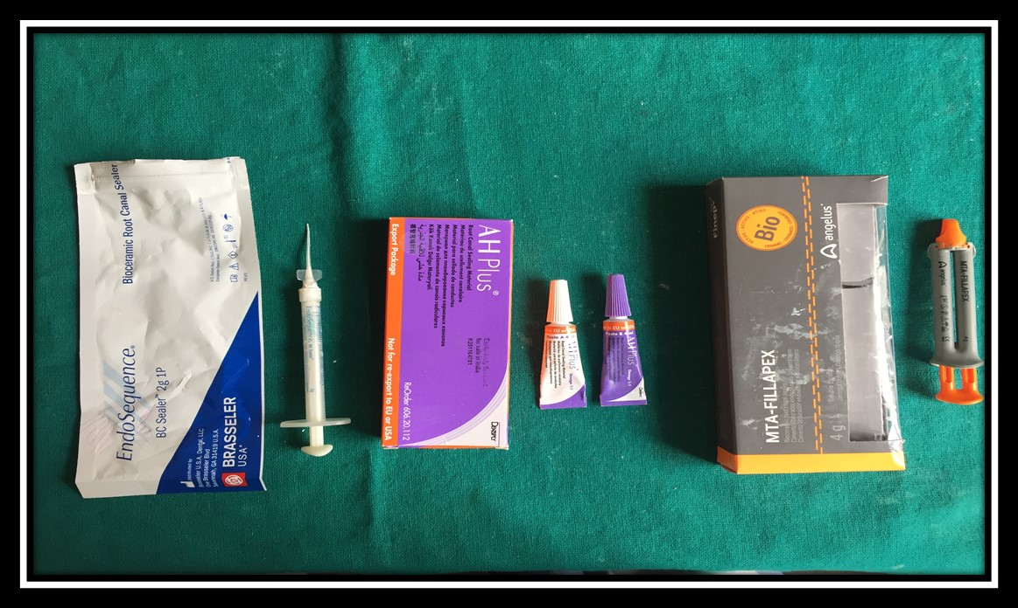
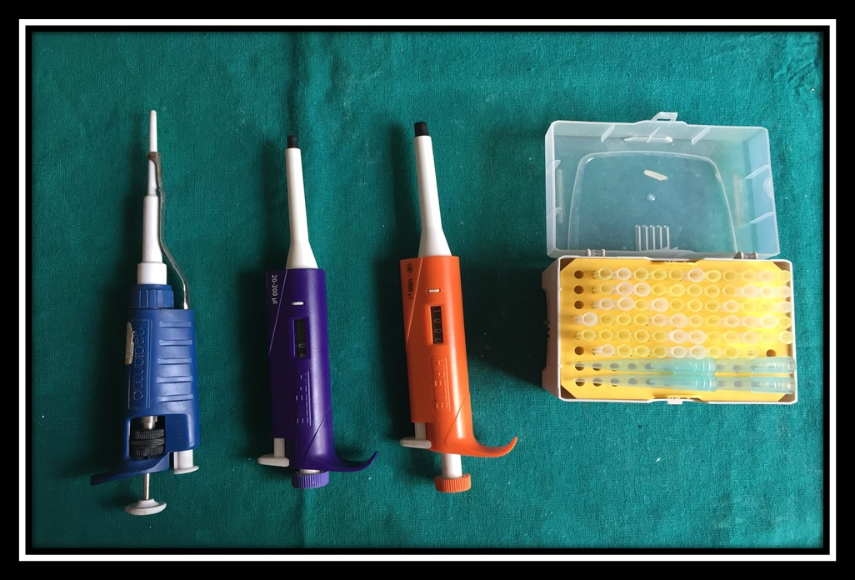2. MICROPIPETTES USED
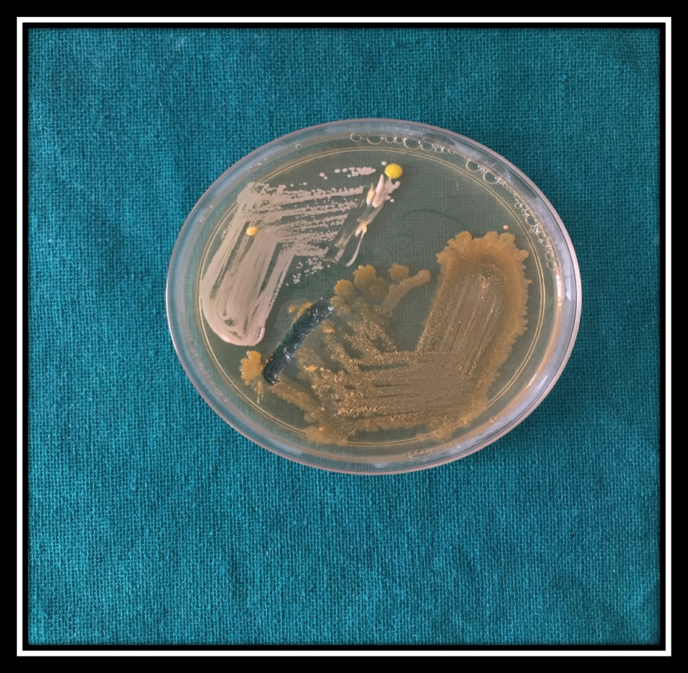
3. CANDIDA ALBICANS
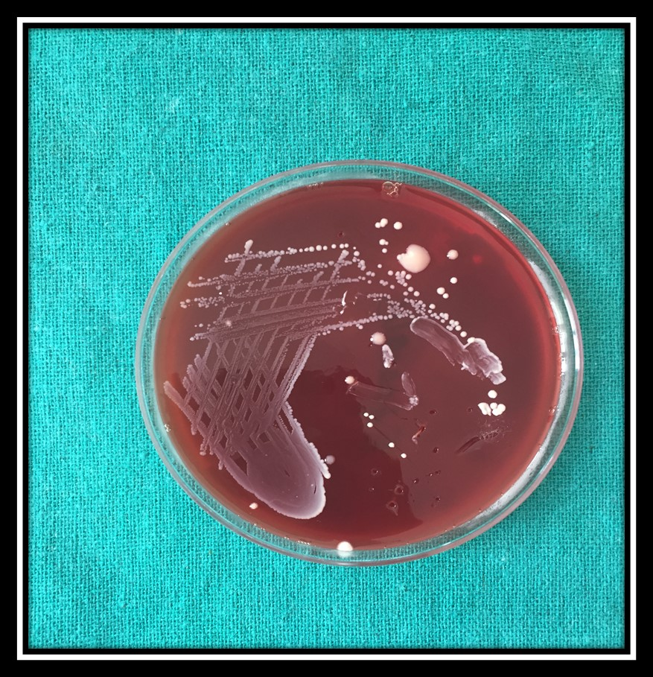 4.STAPHYLOCOCCUS AUREUS
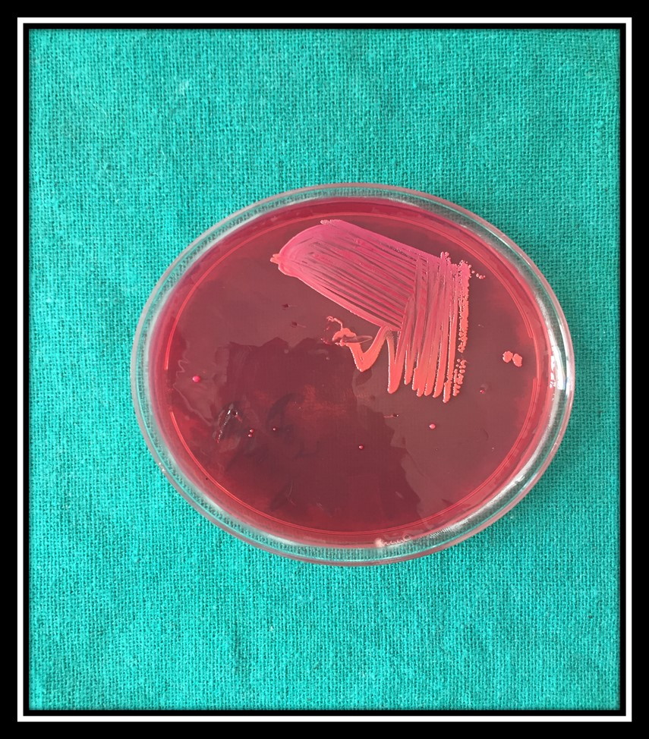
5. ENTEROCOCCUS FAECALIS

